**Git Repository Link** : <https://github.com/gauravMori158/training_simform>

**Profile**

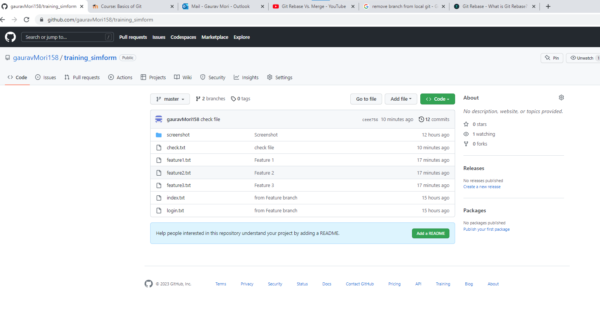

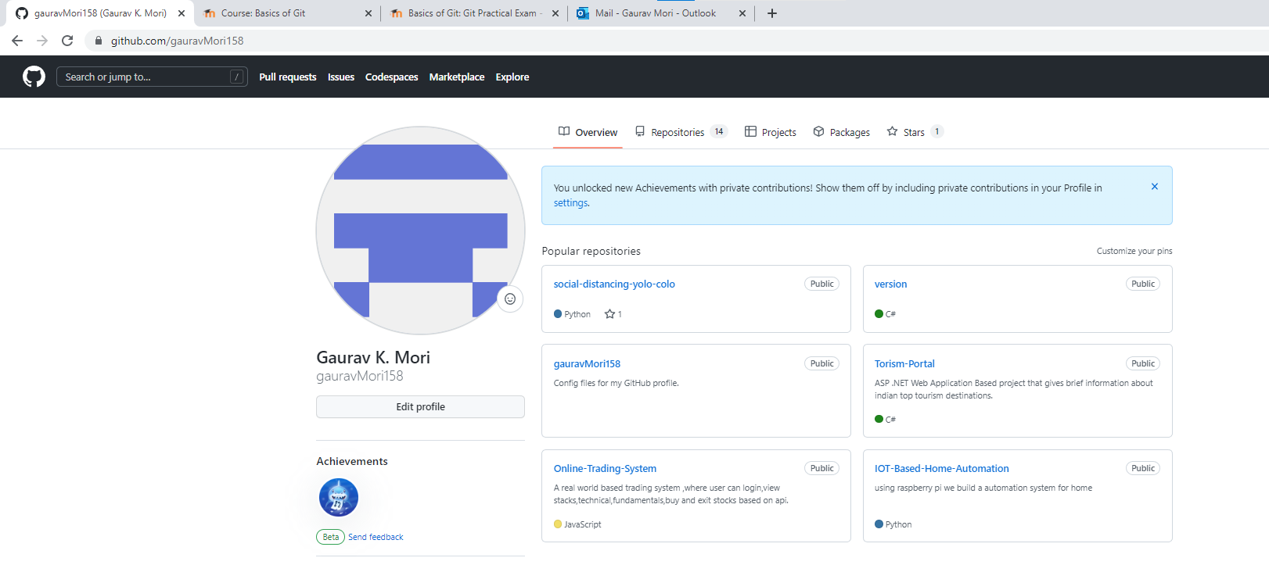

**1. Pull and Merge difference**

**Pull :** used to fetch and download content from remote repository .it copies content remote to local .

**Merge :** Used to merge different branches into one.it merge local branches.

Command

Git init

Touch index.txt

Git add .

Git commit -m “ Initial commit from master”

Git remote add origin <https://github.com/gauravMori158/training_simform.git>

Git push -u origin master

Git branch feature

Git checkout feature

Touch login.txt // modify or make a new file

Git add .

Git commit -m “Second commit from feature branch”

Git fetch

Git push origin feature

Git checkout master

Git merge feature

Git push .

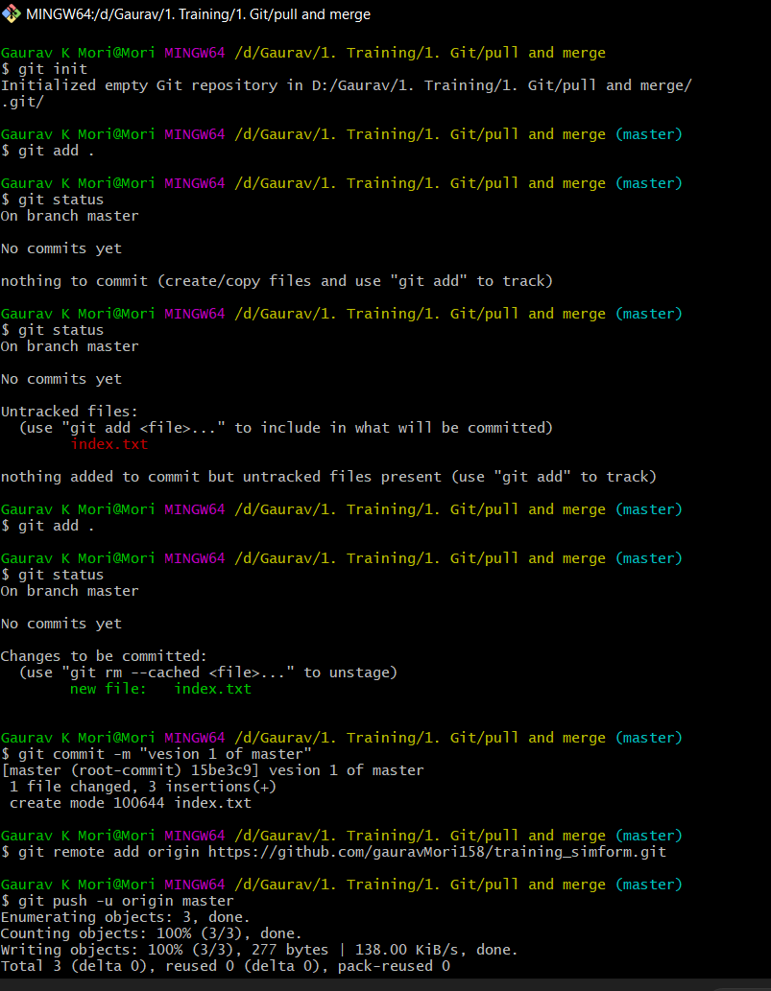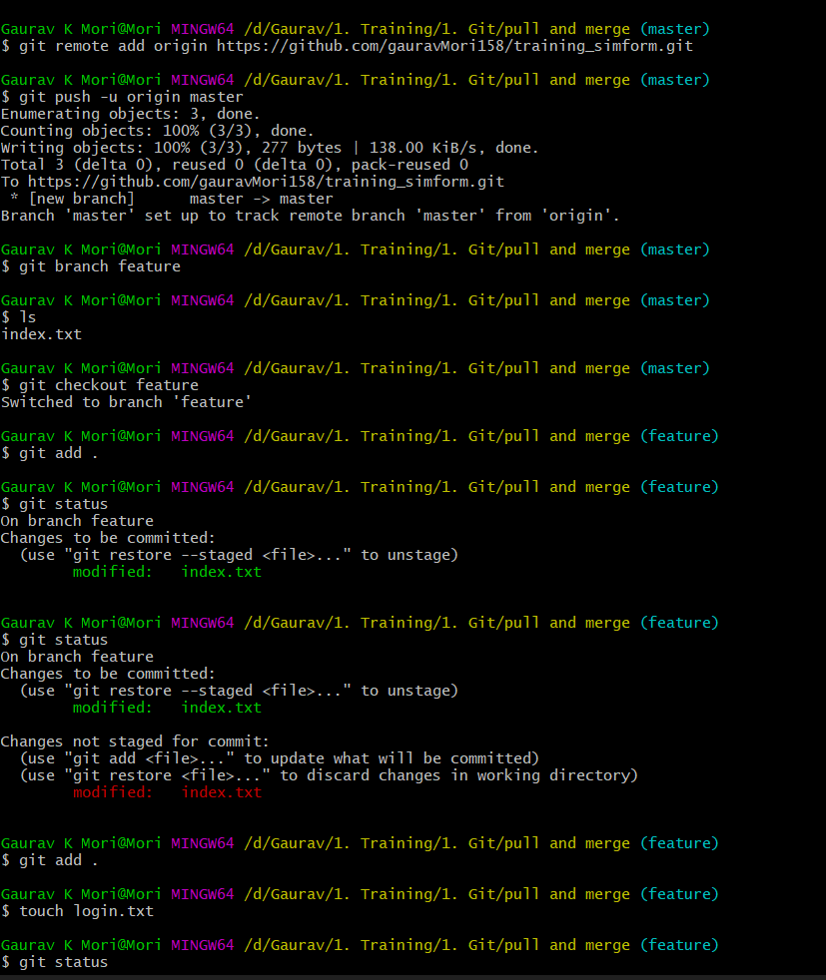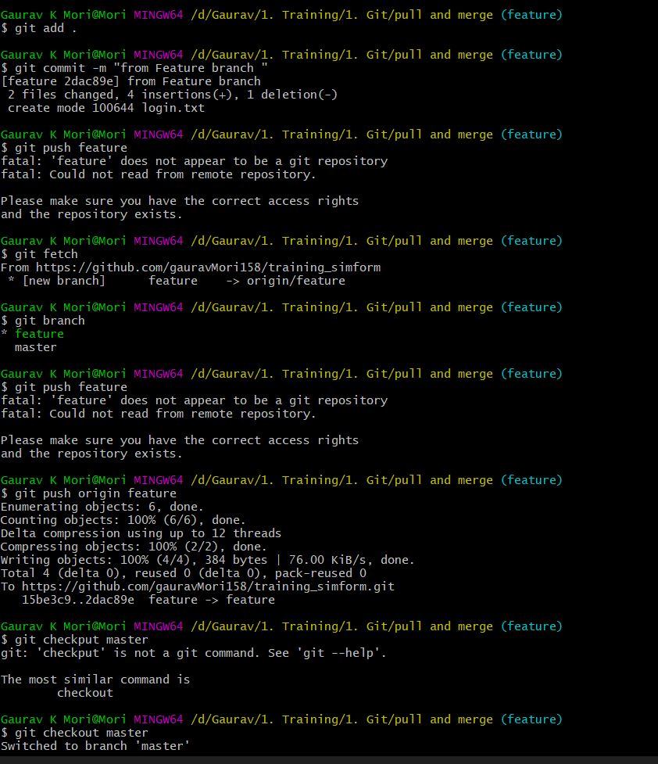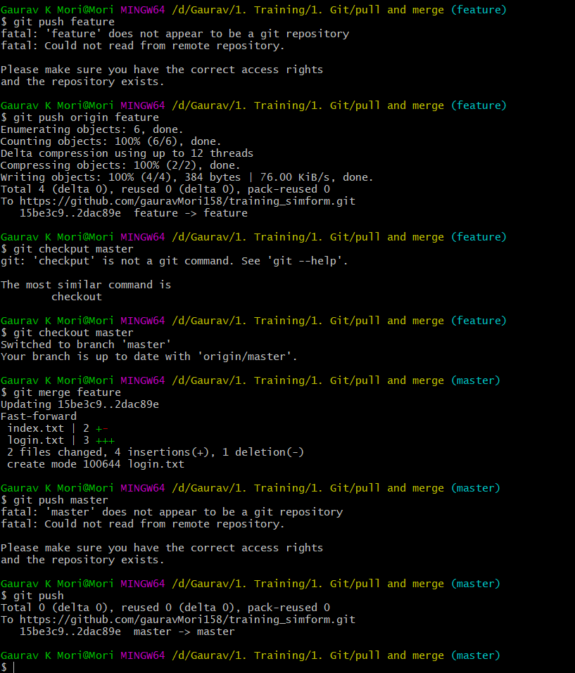

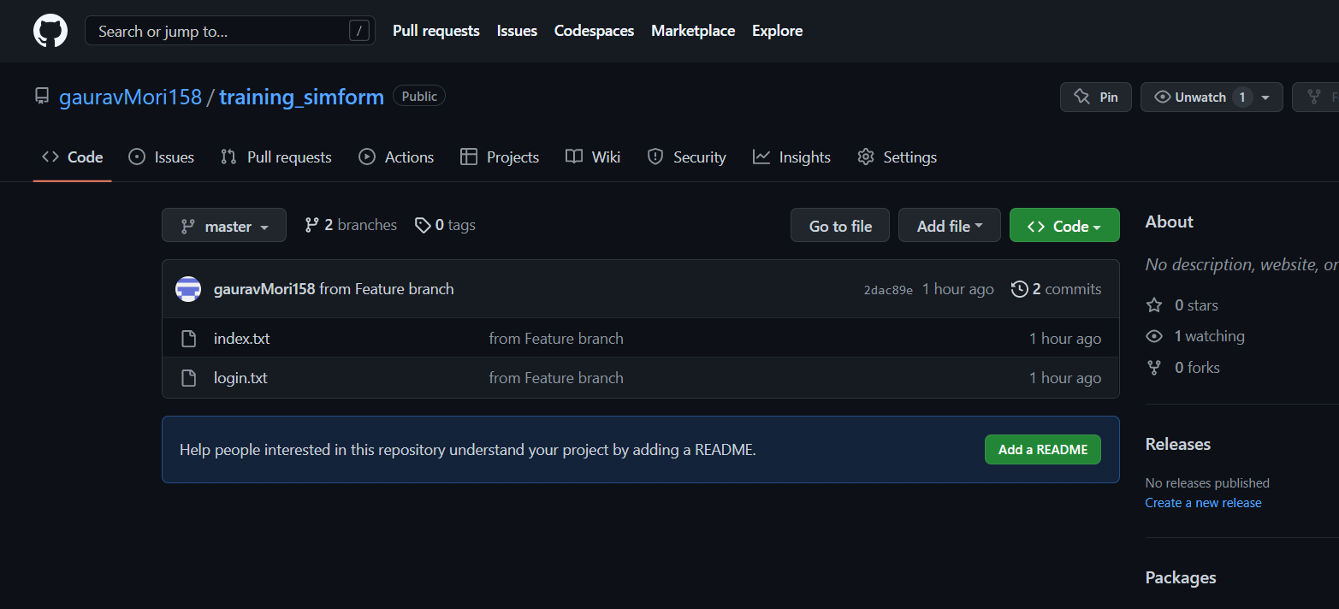

**2. Rebase**

Command

Git checkout feature

Touch branch.txt

Git add .

Git commit -m “Rebase Example”

Git rebase master

Git checkout master

Git rebase feature

Git push

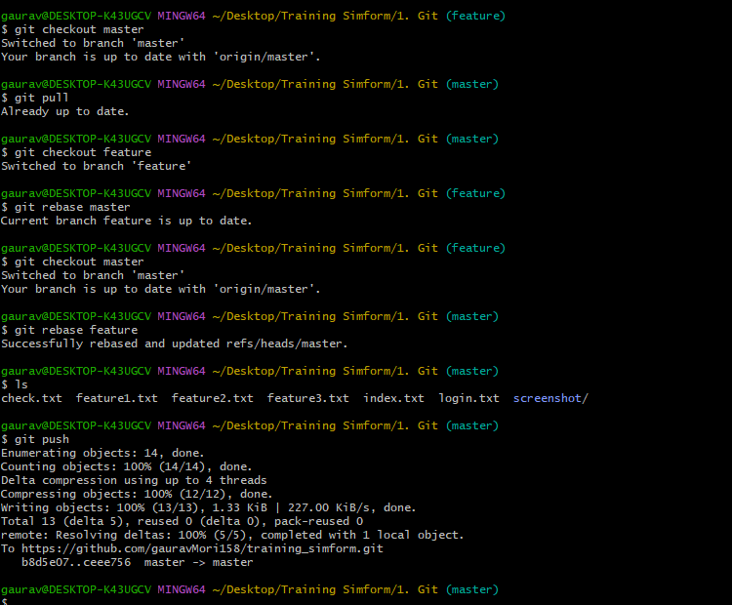



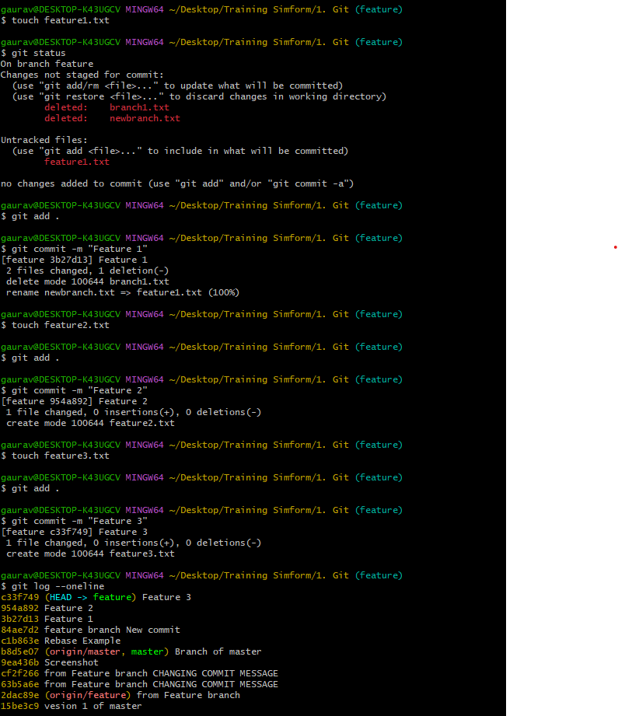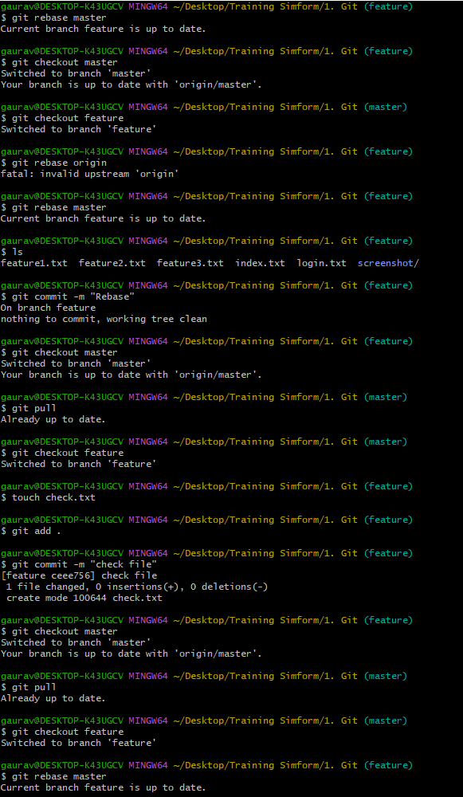

**3. Change commit message**

Git commit – – amend -m “New commit message”

Git push – –force

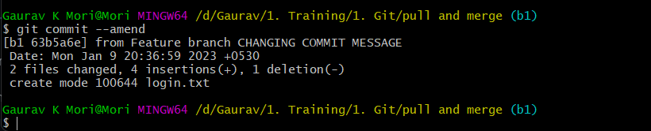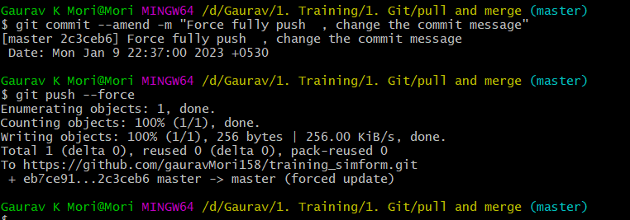

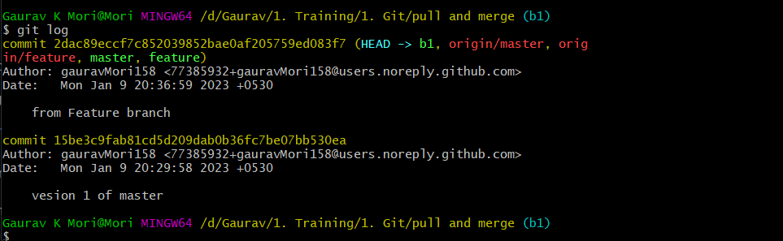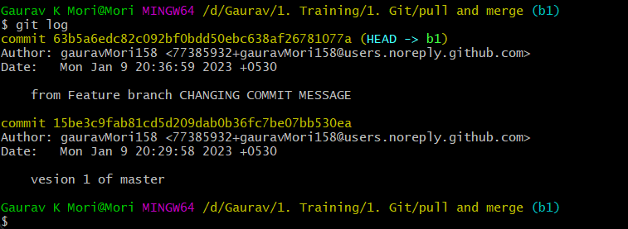

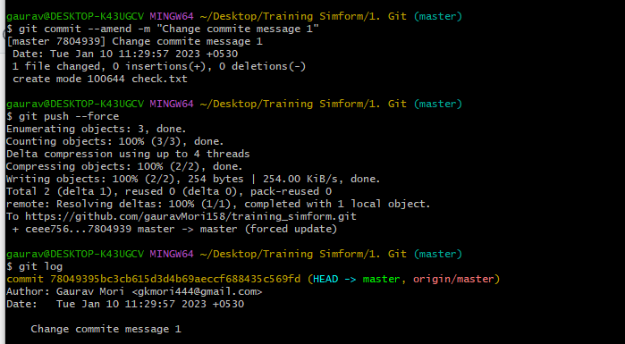

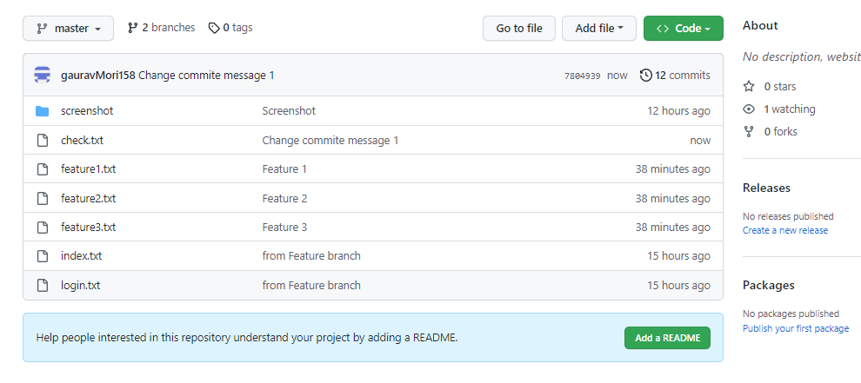

**4. cherry pick**

Command

Git checkout feature

Touch new1.txt

Git add .

Git commit -m “new1.txt”

Touch new2.txt

Git add .

Git commit -m “new2.txt”

Git log – –oneline // copy commit id

Git checkout master

Git cherry-pick command_id

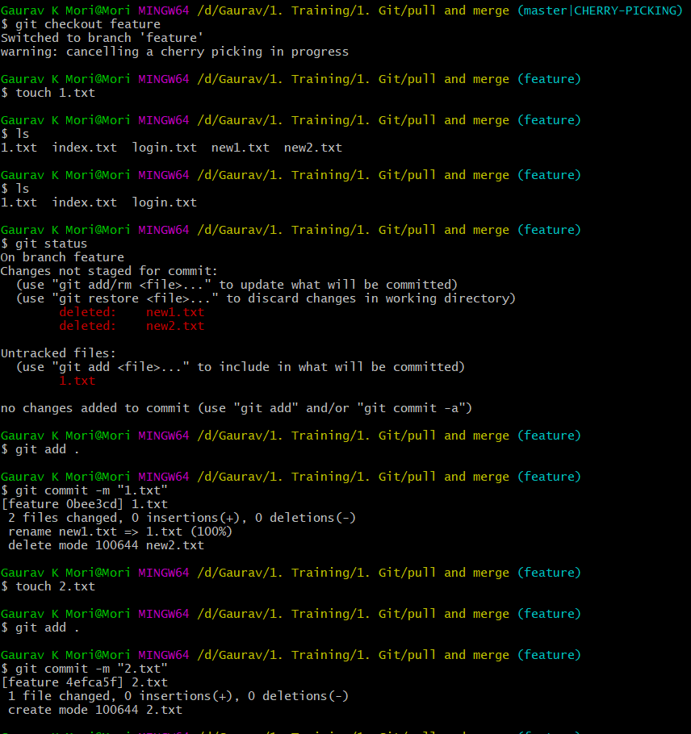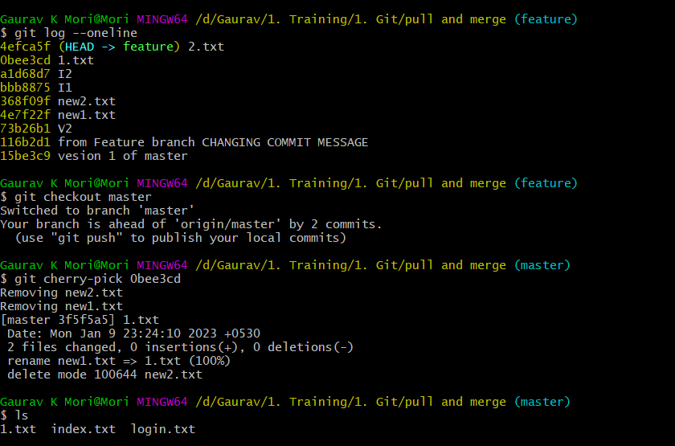

**5. Drop commit**

Commit

Git reset – –hard HEAD^2

Git push – – force

